JHAGADIA INDUSTRIES
ASSOCIATION

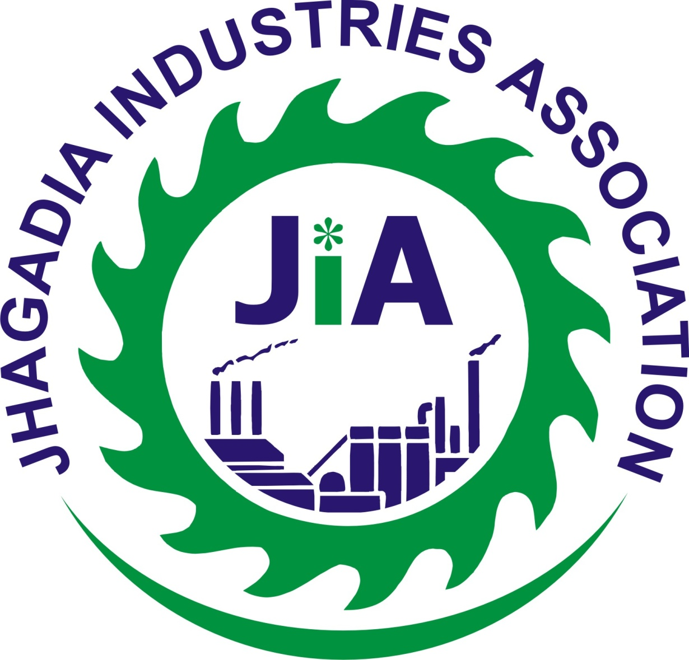

CONSTITUTION
(UPDATED
UP TO 16-10-2015)

----------------------------------------------------------------------------------------------------------------
Plot No. 763/1, 1st Floor, GIDC Jhagadia Mega Estate, Jhagadia-393110.
Dist. Bharuch. (Gujarat), E-mail : info@jia-india.org, Website : www.jia-india.org
This constitution copy is translation in English on the basis of original constitution in Gujarati.
If any dispute arising constitution in Gujarati will prevail over English Version.
On the date 18/10/1997 Jhagadia industries Association meeting was held in which the following resolutions were passed and members were given and Ratification resolution was passed with consent of all members.
Resolution No. 1
The following persons have been appointed in the same meeting in Jhagadia industries Association with the council unanimously passed a resolution.
Mr.S.R Bansal | President
Mr. R.K Khanna | Vice President
Mr.V.S Ravikumar | Secretary
Mr.P.V.Raval | Treasurer
Mr.D.S. Trivedi | ,,
Mr.Vijay Sarthi | ,,
Mr.Shashtriy | ,,
Mr.Veera Raghvan | ,,
Mr.Garg | ,,
Mr.Kothari | ,,
Mr.Dhaigunde | ,,
Mr.R.S.Bapna | ,,
Mr.Pravin Goyel | ,,
Mr.Paramjeetsingh | ,,
Mr.Kamath | ,,

The afore mentioned persons shall be in the name of the Association by their positions.

Resolution No-2

Under the Society registration Act 1860, Jhagadia Industries Association’s President / Secretary are given power for registering , to do signature, make disclosure, and to do all related procedure.
Resolution No-3

Jhagadia industries Association needs to work as per rules and regulations made in accordance with the rules and regulations, and it has been approved unanimously.

President/GEN.Secretary

MEMORENDUM OF ASSOCIATION
JHAGADIA INDUSTRIES ASSOCIATION
- The Board will be named Jhagadia Industries Association
- To date the organization's main office (permanent office) will be D.C.M. Shree Ram Consolidated LTD, Block No. 749 GIDC Estate, Jhagadia and the second space shall be determined from time to time.

- Work Area
To do work around Jhagadia industrial area for the members of this organization. Jurisdiction of activity will be Jhagadia GIDC Industrial and also outside of Jhagadia. To make solution of dispute as per industrial dispute resolution Act of 1947, labour Act and any other law.
The purpose of the Board is as follows.
- To give understanding of Trade, industry, education and research, etc. to all member.
- To provide technical information, and other facilities to all Industries.
- To give Co-operation to all industries and provide other relevant information.
- To provide and engraft advice with regards to commercial, technical, and management services to amalgamate in their business.
- To increase cooperation with industries having similar scope and purpose.
- To conduct project regarding Education, Surveys and Research by its own.
- To organize meetings for exchanging ideas on trade, commerce.
- Pay attention to the activities relating to the Education, Medical, Training and Welfare of workers.
- To work for protecting the member's interest.
- Trade, facilitation of trade development and would increase the scope successively.
- Cooperating with other members of the organization's working with a similar purpose.
- Be aware of all legislative and implementing them.
- To take all legal steps such as to give notice, to cooperate & departmental promotions etc.
- To send Representative or the letter to the Central Government or the State Government to make appropriate representations of matters for related industries.
- To find solution of problems relating to benefits of industries and to take strict action to remove them.

- To resolve disputes between members of organization and to bring the right solution.
- To buy or sale land, assets and other movable or immovable property for organization.
- To prioritize works in benefits of members. To join hands between owner and workers work for betterments of workers.
- To raise money by receiving them as gifts or as donation for betterment of the organization. To withdraw, receive from bank and to do signature on documents
- To discount cheque or bills and regulate Bills of exchange, bills of landing, railway receipt, warrants, debentures and other documents The promissory note shall be raised and implemented.
- Open a Bank account for Association and do financial transactions.
- To participate in the National Exhibition, to give Advertisement and arrange exhibition.
- To education and training for workers.
- Giving the benefit of those who cannot benefit from a member by their own power.
- To cooperate and get co operation from small, medium, large industries which are connected to the central or State.
- Investment of money.
- To improvise in managing / mortgage , deposits, develop, sell, and rent of properties or managing organisational Assets properly.
- To coordinate and make Agreements with central, state govt and local authorities.
- To build confidence and give Assets and Fund of the organization to trustees so that they can be proper and well utilised.
- To take trust's administration.
- To take actions for the benefits of organization.
- To give proper opportunity to member industry for presenting their problems.

We give some of the individuals who signed the name of the address is as follows.
Company Name / Address | Member
D.C.M | Mr.S.R Bansal
VARDHMAN ACRELIC | Mr. R.K Khanna
HUBER CHEMICAL | Mr.V.S Ravikumar
SEARCHCHEM LTD. | Mr.D.S. Trivedi
SWILL LTD. | Mr.Vijay Sarthi
REMI METAL | Mr.Shashtriy
PEPSICO INDIA | Mr.Veera Raghvan
GULSAN SUGAR | Mr.Garg
K.L.J ORGENIC | Mr.Kothari
MTZ POLYMER | Mr.Dhaigunde
AJANTA PEPAR | Mr.R.S.Bayna
SITARAM PEPAR MILLS | Mr.Pravin Goyel
GUJARAT BOROSIL | Mr.Paramjeetsingh
RAJSHREE POLYFILS LTD | Mr.Kamath

Note: - Only the names are displayed. An industrial member is that they are all the same request and sends representatives to sign.
- The following terms are included in this Memorandum.

- Organization or this Association, means, Jhagadia Industries Association in short JIA.
- Auditors, means the persons who are appointed to do audit.
- Managing Committee means working area of representatives. To call representatives (Managing Committee) meeting to manage organisation's work.

- Meeting or General Meetings means, meeting of members industries.
- Annual General Meetings means a general meeting of members called by the Association.
- Special General Meeting or Particular General Meeting, means, additional meetings called by the Association
- Month means, a calendar month.
- Office means, Association’s registered office.
- Seal, means, common seal of the Association.
- Special Resolution or General Resolution means, matter decided after discussion during annual meeting or interim meeting.

- Year, means, a year starting on 1st April and ending on 31st March.
- Written, means, words written in printed forms.
- Constitution, means, Memorandum of Articles of Jhagadia Industries Association.

- Membership
- It is understood that any industry or Company, who is having intention of starting of production, such Company is eligible for membership.

- Existing members are named in the printed form.
- New membership's admission decision will be taken by Managing Committee & their decision will be final.

- Production Industries who are considered eligible for registration, are also considered eligible for membership.

- In case of such industry, whose membership was cancelled, if they again want to take membership, they have to settle their old dues. Thereafter, they have to remit the entrance fee for membership.

- Subscription for Membership
- The industries who wish to take membership, are required to pay annual membership in advance. New Members are require to remit entrance fee along with annual fee.
- At present, entrance fee is Rs. 5000/-
- Annual fees for industries are as given below:
- For investment above Rs. 10 Crores … Rs. 6000/-
- For investment below Rs. 10 Crores … Rs. 4000/-

For Small Scale Industries, 50% concession will be allowed, but they are required to produce Certificate to prove themselves as small scale industry.

- Every year subscription is to be remitted in advance, i.e. subscription for the year from 1st April to 31st March the subscription is to be remitted before 31st March.

- Representation

Company will send their authorized representatives to the sub-committee, giving special authorisation. This Sub-committee will decide them.

- Register of Members

A register is kept for the members, which contain the following details.

- Name & Address of each and every member.
- Type of Industrial activity
- Date of membership
- Date on which the membership is cancelled
- Each member industry should select two members and their names will be in Association’s printed form. They are eligible to vote.

- To cancel the membership

- Member has to send their resignation to the Managing Committee of the Association, and if the Managing Committee accepts the resignation, the membership is considered as cancelled. In that case, the members have to settle their dues.
- Members whose names are cancelled in the Committee of Board (within time limit).
- Notice given for termination of membership to any of the member.
- If working of any member is not satisfactory, they can be terminated.

- Managing Committee :
- Managing Committee will select/notify the following persons.

- President … 1
- Vice President … 1
- Secretary … 1
- Treasurer … 1
- General Members … 2
---------------
Total … 6

- Period of the above said officials will be one year.
- Managing committee is to be dissolved by the General Body in first year.
- If any vacancy occurs due to leaving of any member, any if the vacancy exists beyond a period of month, one person is to be selected by the Managing Committee from the members and that member will have all rights.
- If any member is not qualified according to be below mentioned rules, such member will not be considered as eligible for election.

- He should be regular member from 1st April, i.e. should complete one year of membership.
- Company should settle all dues fully as per the rules and regulations of the Association.
- His nomination is to be authorized. If any member sends nomination for more than one candidate, in that case candidature of all (of that member) will be considered as illegal. Before final , all candidates have settled all their dues.

[NOW AMENDED VIDE 29.09.2001:

- President … 1
- Vice President … 1
- Secretary … 1
- Treasurer … 1
- General Members … 10
---------------
Total … 14
Number of trustee will be 9 minimum, and 14 maximum. Period of the above said officials for three years.

Amendment on dtd. 16/10/2015
Altered provisions of sub clause (a), (b), (c) of clause 6 of the Original Memorandum of Association and Article of Association provides as under :
In order to have sustainable and inclusive growth of M/s Jhagadia Industries Association and to bequeath equal representation to all classes of members of M/s Jhagadia Industries Association , total number of members of Managing Committee of JIA is decided to be 10.
The appointment of members of Managing committee of JIA shall be as under:
01) Maximum 8 representative from Large and Medium scale
member industries.
02) Maximum 2 representative from Small Scale Industries.
03) Minimum number of members of Managing Committee shall be 9
and maximum number of members of Managing Committee shall
be 10.
The members of Managing Committee of M/s JIA shall make appointment for following positions as under :
Sr. No. Particulars No. of representatives
01 President 01
01 Vice President 01
01 Secretary 01
01 Treasurer 01
01 Committee Members 06
Total 10
Minimum tenure of Office bearers of JIA and Members of Committee Members of JIA shall be of 3 years.
The Office bearers of JIA and Committee Members of JIA shall automatically be vacated from their offices at the completion of 3 years but shall continue to hold their existing office until new Managing Committee is formed and new Office bearers of JIA are appointed and all the existing powers and responsibilities shall remain intact.

- Method for Giving Vote

- Secretary will bring notification of election 60 days before election date. Within 15 days eligible candidates will be selected. Election will be conducted before 30th April.
- Ineligible of the members of managing committee & other information like due of current year etc. will be shown in notice.
- After receiving of all papers of nomination, the same will be kept with the Managing Committee. List of the same will be circulated by the Secretary within 15 days. In this notice the last date for withdrawal will be shown which should be 10 days before the date of election.
- Nomination form can be withdrawn by submitting written application.
- After the last date of withdrawal, the Secretary will publish the list of the remaining candidates.
- Election can be conducted only when there is majority of 1/3rd of the members.
- For the election, election officer will be appointed by the President and he will be from members of JIA. He will be assisted by more than one election officials. In case of any disputes in the election, the decision of the Managing Committee will be considered as final and that will be binding on all members.
- The decision of the Managing Committee will be binding on all members for all matters like withdrawal of nomination, letter, counting of vote, etc. No technical mistake will be considered in counting of votes. Election should be planned before the annual policy of the Association. Time and date will be decided by the Managing Committee.
- Third person will not be permitted.
- To implement the object of election, authorized representative can recommendation again in the name of Jhagadia Industries Association.
- Eligibility for voting.
The last date for clearing dues will be considered as 31st March. Till that time advance fees should be received by Association.
- In voters list, no amendments will be made from 1st April till the date of election.

Amendment in Voting Right vide amendment dtd. 16/10/2015
Altered provisions of clause 14 of the Memorandum of Association and Article of Association provides as under:
It shall be prerogative of the President to determine the methodology of voting at every Annual General Meeting. The President's decision in respect of methodology of voting at every Annual General Meeting shall be taken after the due concurrence of the members present and voting at every Annual General Meeting.
The voting right of members at every Annual General Meeting and/or Extraordinary Annual General Meeting shall commensurate with the Plot size holding shall be determine as under :

Sr. No. Particulars of land holding No. of Votes
01. Upto 10000 square meters 01
02. Above 10000 square meters but upto 50000 square meters 02
03. Above 50000 square meters but upto 100000 square meters 03
02. Above 100000 square meters but upto 300000 square meters 04
02. Above 300000 square meters 05

Voting at every Annual General Meeting and/or Extra Ordinary General Meeting shall be done by one representative of members industries but at the time of counting of votes, number of votes to be assigned to it, shall be in accordance with the provisions explained in para above.
Decision of every Annual General Meeting and/or Extra Annual General Meeting shall be taken on the basis of majority of votes. However, at the time of computation of majority votes shall be done as per the provisions explained in above para.

- Additional Member

Whether Additional member of the Managing Committee is or is not member of association & those people who are not ordinary member of association then these people will not be eligible to vote in the Managing Committee meeting or any other meeting.

- Value of President’s Vote

In all matters including election & specially which are decided by consent of the members. If voting is necessary say whatever decided by the President in the meeting or decided by ordinary majority & if there is any difference in voting then the President’s vote will prevail and final.

- Membership in Managing Committee.

Membership from the Managing Committee will be automatically cancelled, if in case of member remains absent for three consecutive meetings and do not intimate the reason of non attendance to the Secretary by letter, telegram or letter under postal certificate & then before considering that members, Managing Committee will question the member suitably and suitable decision will be taken that the whether member was absent for three meetings without informing in writing. Thereafter this member should have paid all his dues before 31st March otherwise member will be dismissed from the Managing Committee.

- Advantage of Managing Committee Membership

The responsibility of the Managing Committee will be to fulfill aims and objectives of Association.
- pass resolution in the meetings and review time to time the objectives of the Association.
- To control the expenses and income, to deposit the receipts of association in nationalized bank and that accounts to open by one or two persons from the following:
- President
- Vice President
- Secretary
- General Member
- To present the problem of members of Association

9) Quorum:

Quorum for managing committee will be of four members. If quorum is not there due to less number of members then the secretary will organize another meeting.

10) Essential Meetings

The Secretary has to call general meeting of association within 20 days time. If the meeting is necessary by any member it can be called. Required matters are to be discussed in the meeting and it should be put on notice board and in addition to that particular matter no other matter will be attended/considered.

11) Managing Committee Meeting (Special):

The Secretary can call the Managing Committee meeting within 10 days time, by the majority of 1/3 of the members. Important issues are to be discussed in the meeting and these notice to put on notice board. No additional matter will be attended/considered.

12) Annual General Meeting

This meeting is to be held once in a year and the date of the same is to be decided by the Managing Committee. In this meeting matter of business and working of association will be discussed. Intimation about this meeting is to be given to members 21 days before the meeting date.

13) Annual Business Meeting

In this meeting the below given points will be discussed.

- To consider the annual report.
- To discuss about the balance sheet and the annual statement of bank.
- To update/discuss about the voting results of election conducted by the Managing Committee.
- To consider for the appointment of the Auditor
- Discuss upon any additional points or any other question brought by members in the meeting.

- The Association 's Extraordinary General Meeting
Managing committee will call this Extraordinary General Meeting by the 1/3rd majority of the members. The meeting shall be held within 15 days. Notice of the meeting will be given 1 week before the meeting. If the Managing Committee fails to held this meeting within 15 days then another date will be determined by the member's consent. President or Vice-President shall hold meetings on behalf of the Association. In their absence, meeting will elect President for this particular meeting. If the question arised in election for right candidate in the polls then the President will use his valuable vote.
- Election
How to vote in General Meeting will be decided by the President of the meeting and that decision will be taken with the consent of the members .
- Quorum
1/4 majority of Board Member required for quorum. If the quorum is not present within 15 days than meeting will be postponed. However, after 15 days the member can create their own quorum.
- Notice of the meeting not received by the Member
It will not be considered as appropriated reason for not attending the meeting by the members that notice of General Meeting was not received as sent on any of the address provided by members. But if the President is satisfied that the member has not received Notice of Meeting then the date old Meeting will be cancelled and new meeting will be held within 3 weeks and a information of this meeting will be given to members before 1 week of meeting.

- Notice
All Notices must be given to members. If possible notice can be given immediately. But if it is to sent by the Post it should be sent through Postal Certificate.

- All members of the Managing Committee of the Board will give Honorary Service
- Office staff, functions and duties.
- Affairs of the General body and Committee Meetings will remain with President & President will use his power & right whenever it is required. President will work as per guideline of the association.
- In the absence of President, Vice President will do all the works. In the absence of Managing Committee, President will do his work.
- Secretary’s function and duties:-
- Secretary will maintain the minutes of meeting & each register and will stand true on the faith of committee.
- The secretary will have the authority to spend up to Rs 1,000 on behalf of the Association.
- Treasurer rights and duties:-
- The treasurer of Association will held all Fund (Cash) of the association and it shall be deposited in the bank and this amount should not be less then Rs. 2000/-
- Accounting of all the money for which receipt is issued.
- To tally account statement of Revenue and Expenditure of the association and to monitor it.
- Make payment of all vouchers passed by Secretary and to sign on the vouchers.
- Arrange audit for the annual accounts.
- To present the the Annual Balance Sheet, Income and Expense Account of the Association in AGM.
- Rights and duties of a member.
Under the Industrial Disputes Act, 1947, member of the Board must be suitably qualified for the interest calculation. For the sake of the interests of the associations members should be eligible for any representation or recommendation.

- Accounting Year of Association must have been finalised.
Fund of the Association:
Fund of the association should be used as per the Constitution of Association and fund should not be transferred directly or indirectly without the consent of Managing Committee. Annual audited statement of accounts must be made by Managing Committee every year and permission of Association is required for how much expenses to incur for the same.

- Amendment in the Constitution
No amendment can be made in the constitution without the majority of 3/4th of the members in General Meeting. If any of member of Association wants to amend constitution then he needs to inform the same in writing to the President and Secretary will make the notice of this with in 30 days and inform to all the members in this matter.

- Law and legally representation
Decision of the President will be binding on all the members of the Association inspite of various opinions/disputes of members. If any of the member not agreeing the decision of the President then he can go for appeal. For the same he will call Special General Meeting. Judgment of the Special General Meeting shall be binding on all members of the Association.

H) Dissolution of the Association
- The Association can be dissolved by calling a special meeting. In such meeting there should be at least 1/3 rd of the members. It can be dissolved by holding election and with the majority of 3/4th of the members.

Adhoc Committee :
On behalf of and representing JIA ,some persons whose name and address which are listed below, are intend to join constitution.

